Register Program User Guide

CS 3450

Grant Russell

Daniel Oliveros

Introduction

This program is used to purchase items at a store, it displays a GUI that allows a cashier to do all of the necessary tasks that have something to do with this. It also allows higher level staff (managers, owner, etc.) the ability to change elements in the databases.

Guide

There are two main functionalities to this system. The checkout functionality and the Back Office. We will give a general usage description of how to use these two.

1. Checkout:

In order to access the Checkout screen you must log into a user account. First, click on the “Checkout” button from the main screen.

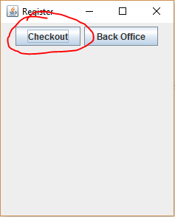

After this, you will be taken to the log-in screen, in order to actually process transactions, you must be logged into a user account, log in using whichever user account you have set up for yourself and then you will be sent to the following screen:

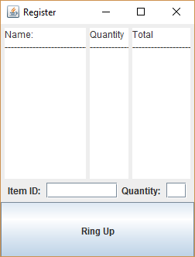

To add items to this purchase, just type in the item’s ID and the amount of it you wish to sell, press the enter button and this will be added to your purchase. Once you are done adding items to this sale just click on the “Ring Up” button located at the bottom of this screen.

A receipt will be shown, after pressing the “OK” button you’ll be taken back to the main screen.

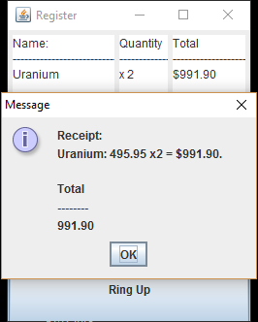

1. Back Office: This functionality is intended for data management. It allows the user to change easily the different users and items being used. To access this functionality, log in after clicking the “Back Office” button, unlike the cashier functionality, only users of level 2 or above are allowed to access this functionality.

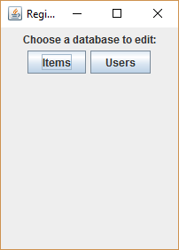

After clicking any of the two options, the user will be sent to an input screen where they are prompted to input the ID of the element being edited. For simplicity’s sake, we will only look at the view after clicking the “items” database, all of the important elements for database editing work similarly for the different databases.

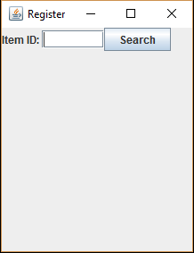

Input a valid ID and press the “Search” button.

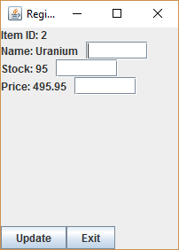

On the left, you’ll see the current values for this item being displayed, if there are any changes you’d like to make write the new value you’d like to give it, then press the “Update” button. Otherwise, press the “Exit” button to be taken back to the main screen.